Government Degree College

Pendlimarri, YSR Dt.

FACULTY PROFILE

* Name of the Lecturer : Muthukur Thaidun

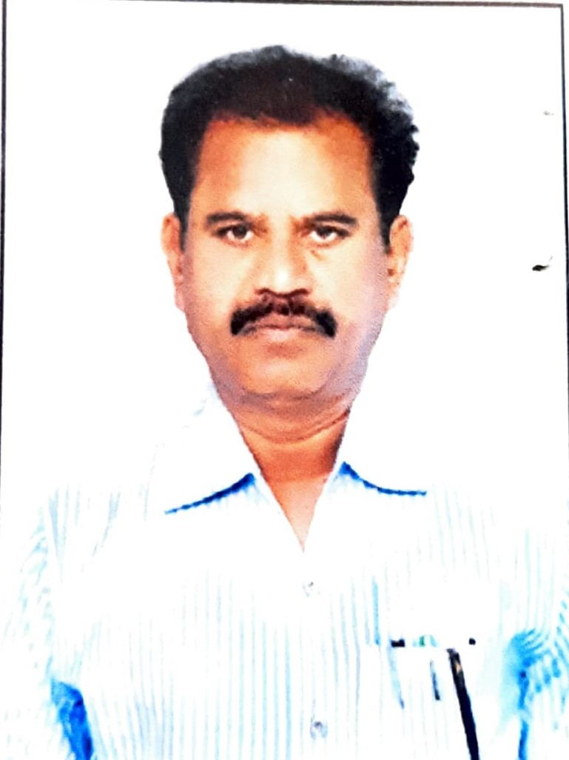

* Designation : Lecturer in Physics
* Present Address : Government Degree College

Pendlimarri,YSR Dt.

* Mobile No. : 944114805
* E Mail ID : muttukuri.thaidun@gmail.com
* Qualifications : M.Sc.,

|  |  |  |  |
| --- | --- | --- | --- |
| **Name of the Degree** | **University** | **Year of Passing** | **Division** |
| B.Sc. | S. V. University         Tirupathi | 1983 | Secund |
| M.Sc. | S. K. University      Anantapur | 1989 | Secund |

# Teaching Experience :

# More than 25 years of Teaching Experience in Government Degree colleges from 20-03-1998 onwards.

# Appointment Particulars :

# Appointed as Lecturer in Physics at Loyola Degree College(YSR), Pulivendula, YSR (Dist). Appointed on 20-03-1998. Served in the college from 20-03-1998 to 08-10-2021.

# Present working as Lecturer in Physics at Government Degree College, Pendlimarri, YSR Dt., from 09-10-2021 to till to date.